CLOVER COUNTY FAIR

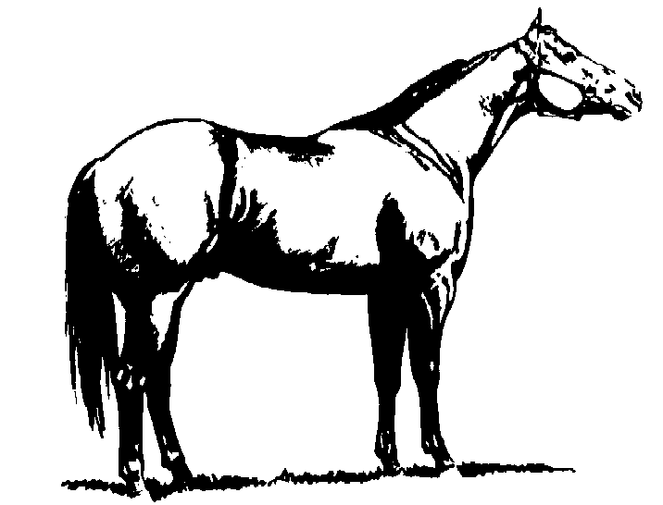

4-H MEMBER:___________________________
NAME OF ANIMAL:_______________________
BREED:________________________________
SEX:_____________ AGE:________________

