
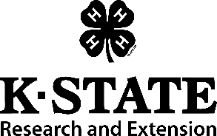
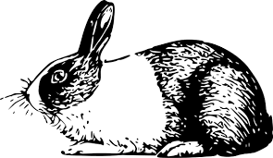

4-H MEMBER:___________________________________
NAME OF ANIMAL:_______________________________
BREED:________________________________________
SEX:____________ AGE:_______________
CLOVER COUNTY FAIR

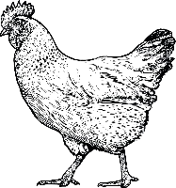
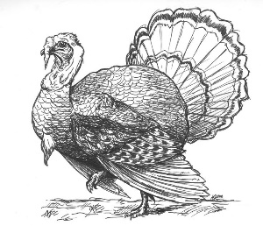
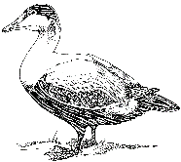

4-H MEMBER:___________________________________
NAME OF ANIMAL:_______________________________
BREED:________________________________________
SEX:____________ AGE:_______________
CLOVER COUNTY FAIR

